Urban Aperture and Gravitate present…
REDEMPTION
Wine and Prophecy in the Land of Israel

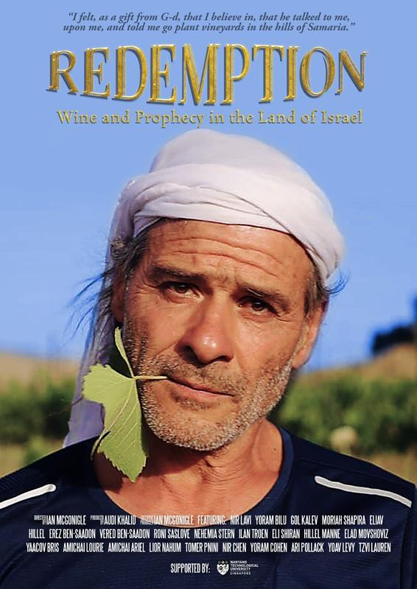
A documentary/ethnographic film by Ian McGonigle
RT: 77 min
Format: HD ProRes MOV; DCP
www.filmfreeway.com/RedemptionFilm

Publicity and International Sales:
Ian McGonigle, redemptionwineandprophecyfilm@gmail.com

LOGLINE
After two thousand years in exile, Jews returned to their Biblical roots in Israel. This film investigates the religious motivations of the region’s winemakers.

SYNOPSIS
After almost two thousand years in exile, Jews returned to their ancestral homeland and, in 1948, established the State of Israel. In 1967, when Israel conquered the West Bank from Jordan, Jews rushed to return to their Biblical roots in Judea and Samaria. Despite decades of bitter conflict with the resident Palestinians, Jews continue to settle these contested territories. Some regard this return as the realization of Biblical prophecies, as part of the process of redemption. This film attempts to understand the beliefs and motivations of the settlers through the stories of the region’s winemakers.

DIRECTOR STATEMENT
He lifted up the bottle and studiously examined the label, a gentle squint revealing his disapproval. The wine was from the contested territories. While spending a year in Israel doing anthropological research for my PhD on human genetics and its role in national identity formation, I realized during a dinner party that in Israel wine is both a political and a religious issue. Wine is an important part of identity formation and wine from the contested territories – what some call Judea and Samaria, or the West Bank – is a hotly divisive issue. Some Israelis see the planting of vineyards in this area as an illegitimate and exclusive claim on the land at the expense of the Palestinians, while others see Jewish return to the area as a realization of ancient Biblical prophecies, as part of a predestined redemption. After I finished my project on human genetics, I decided to visit these wineries and interview the winemakers to better understand their beliefs and motivations for settling these areas; and in particular, to get a sense of the symbolic and spiritual importance of wine in their lives. A few years later, after I started a job as an Assistant Professor of Sociology in Singapore, where my research was supported with a generous start-up grant, I began learning about photography and film, leading me to return to Israel to interview the region’s winemakers on camera. This film is the product of those trips and I hope that by understanding the beliefs and motivations of the winemakers, we may better understand the complexity of this fraught region and also learn something about the ancient and important role of wine in religious Jewish life.
Ian McGonigle

FILMMAKER BIOGRAPHY
Ian McGonigle - Director
Ian McGonigle was born in 1984 in the town of Drogheda in the Republic of Ireland. His father was an electrician and his mother ran a pre-school. He grew up in the small town of Skerries in North County Dublin where he spent his youth racing sailboats. He was educated at Skerries Community College and at Trinity College Dublin, where he studied the sciences. Upon graduation, he went up to King’s College Cambridge for a PhD in biochemistry where he became distracted by anthropology, leading him to a masters in anthropology at the University of Chicago, and a second PhD, in anthropology and Middle Eastern studies, at Harvard University. His dissertation, ‘Genomic Citizenship,’ was awarded the Association for Middle East Anthropology dissertation award and became a book published with MIT Press. In 2018, he took up a Nanyang Assistant Professorship at NTU in Singapore with a grant to launch a ‘Science and Society’ research group. He is currently doing ethnographic work with religious Jewish winemakers in the contested territories of Israel/Palestine.

Audi Khalid – Producer
Audi is CEO of Urban Aperture, a Singapore-based production studio with a focus on commercial and corporate visuals. From idea to image and script to screen, Urban Aperture realises your project for a social generation.

Gloria Daysor - Post Producer
Gloria is a versatile and innovative producer with extensive experience in brand development through video production and creative business communications. A graduate of Media Studies from the Royal Melbourne Institute of Technology, Gloria began her career in television, learning production from ground up. She learnt the ropes of shooting, interviewing, editing and producing TV series, corporate films and online content for government, local and international agencies. Her passion led her to London, where she attended the New York Film Academy and further honed her craft in storytelling. Since then, she has been telling stories for clients by her ability to get the best people for the job. Galvanizing the team and delivering the best story possible by wearing many hats in accordance to different needs of each project - as a researcher, writer, director, editor. But most of all as a producer who made it happen. She understands both client and working teams’ interests and practices open communication to problem solve, which keeps clients returning. When she is not crunching numbers or buried in projects, Gloria can be found in her kitchen, secretly training to be the next Masterchef.

Pinky Vierra – Editor
Pinky’s love for the silver screen started when she was 7, shooting and editing family films on Super 8. In her early teens, little did she know that compositing 8-bit images of her friends and their celebrity crushes on a Macintosh was a prelude to career later in post production. Right after her Communications degree, Pinky enrolled herself in a Producing and Directing course at the University of Southern California, where she immersed herself in film production and editing. She started her online editing career working on TV commercials and films in the Philippines. Further expanding her repertoire of skills to producing, directing and offline editing for corporate films and webisodes. Her expertise as an online Henry and Smoke artist specifically for TV commercials, documentaries and feature films led her to work in Jakarta, Hong Kong and Singapore. With two decades of post production experience, Pinky enjoys both offline and online editing. She loves shaping stories, giving the pulse and life to whatever she cuts. When no one notices the visual effects and is drawn to the story, this is her forte when it comes to online finishing. She calls it being invisible and she knows she’s done the job right.

Azman Mohamed – Colourist
Azman Mohamed is one of the founding partner of Gravitate and has been its resident colourist since its inception in late 2012. With almost 20 years of experience in post-production, he has gathered a wide array of skills from his days in audio production through to colour grading. Adding his dedication and skill to every project and referencing his passion for music and training in fine arts, Azman Mohamed aspires to create works of exquisite beauty and intense drama. His work experiences throughout his career extend across a broad range of genre from television commercials to feature films and documentaries. Whether it’s a movie or TV ads, Azman enjoys the process of telling a story through colours and bringing the imageries to life. Through colour isolation, power windows and skilled use of colour palettes, Azman Mohamed diligently worked with filmmakers, directors and cinematographers to realize their vision and storyline. He also enjoys getting involved early in the process from conceptualisation to fruition of the work. In 2016, Azman won 2 awards for Best Colour Grading in the Long-Form and Short-Form category for HBO Series “Halfworlds” and Eric Khoo’s feature “Cinema” respectively at the Asia Image Apollo Awards. Apart from his work, Azman is also passionate about music having performed locally as well as overseas. His music has brought him from concerts and music festivals to the hall of the United Nations. He plays a clay flute called the Ocarina and has played in the recording of some of the most famous songs by artist such as Stephanie Sun’s “My Desired Happiness (我要的幸福)” and J J Lin’s “1000 Years Later (一千年以后)” to name a few. He also had several albums to his name.

Xander Toh - Audio Post
With a deep passion for music and sound, Xander enjoys working closely with other creative professionals to craft compelling stories and has many years of experience, working on various meaningful projects throughout his career, such as: Crazy Rich Asian (ADR), NETFLIX Marco Polo Season 1 and 2 (ADR), HBO Half Worlds Season 1 and 2 (Dialogue editing, ADR and Ambience design).

Yap Qian Yin - Trailer Editor
Yap Qian Yin is a multi-disciplinary editor based in Singapore with a BFA in Media Art, Specialising in Animation. Notable editing works include ‘sem;’ which received recognition from a local newspaper on raising awareness in mental health. She is conversant with every aspect of post-production, from motion graphics to visual effects, and aims to hone her craft in editing to create compelling films that entertain and inspire.

About Urban Aperture
Urban Aperture is a Singapore-based production studio with a focus on commercial and corporate visuals. From idea to image and script to screen, we realise your project for a social generation.

About Gravitate
At Gravitate, we are passionate about what we do. With a team of storytellers, creative and dynamic, we are always ready to provide solutions for your media and post needs. We work in close partnership with a variety of clients from multinational corporations, advertising agencies and production houses to create compelling stories. Be it corporate or promotional videos, commercials, documentaries, music or feature films, we are able to bring in our collective expertise, objectivity and experience into every project. From conceptualization, production to post production, we have a solid understanding of how to communicate your message to your audience. Our Post-Production Facility comprise of Editing and Davinci Resolve Colour Suites, Online Finishing Suite as well as 3D and 2D Motion Graphic Support. Our suites are also 4K ready for projects requiring extra processing capabilities such as those shot on RAW format cameras such as Alexa, Blackmagic URSA, Sony, RED and many others. Our friendly team is made up of versatile talents who are experts in the fields of Producing, Narrative Editing, Digital Intermediate Colour Grading and Styling, Online/Special FX, Compositing, Digital Cleanups, 2D Motion Graphics & 3D Animation. This means we are efficient, we have the experience and we are reliable. Always looking for creative ways to maximize the effectiveness of your project to deliver on time and on point.
CREDIT LIST
Directed by
Ian McGonigle

Produced by
Audi Khalid

Production Companies
Urban Aperture, Gravitate

Post Producer
Gloria Daysor

Editor
Pinky Vierra

Colourist
Azman Mohamed

Audio Post
Xander Toh

Trailer Editor
Yap Qian Yin

